Academic Year: 2024-25 | Year: First Year | Term: I
Roll No.: | 11
Name: | Riddhee Sandeep Kulkarni
Subject: FCP
Assignment No.: | 24
Title: | Dynamic Memory Allocation
Date:

Contents
1. Theory (Logic) 2
2. Pseudo Code 2
3. Program Code 2
4. Output 2
5. Conclusion 2

THEORY:

This code displays Dynamic memory allocation using malloc(), calloc(),

free(), and realloc(). It is essential for efficient memory management in C.

PSEUDO CODE:

Step 1: Start

Step 2: define pointer and integer

Step 3: accept a number from user

Step 4: write pointer for malloc and free and execute

Step 5: write pointer for calloc and free and execute

Step 6: print output

Step 7: end

PROGRAM CODE:

#include <stdio.h>

#include <stdlib.h>

int main()

{

int* ptr;

int n,i;

printf("Dynamic memory allocation using 'malloc' function");

printf("\nEnter the number of elements: ");

scanf("%d",&n);

printf("\n");

printf("Entered number of elements %d\n",n);

ptr = (int*)malloc(n* sizeof(int));

if (ptr == NULL)

{

printf("Memory cannot be allocated!");

exit(0);

}

else

{

printf("Memory successfully allocated using malloc");

for (i=0; i<n; ++i)

{

ptr[i] = i + 1;

}

printf("\nThe elements of array are: ");

for (i=0; i<n; ++i)

{

printf("%d",ptr[i]);

}

}

printf("\n");

printf("\n");

free(ptr);

printf("Memory successfully freed.");

printf("\n");

printf("\n Dynamic memory allocation using 'calloc' function");

printf("\nEnter the number of elements: ");

scanf("%d",&n);

printf("\n");

printf("Entered number of elements %d\n",n);

ptr = (int*)calloc(n,sizeof(int));

if (ptr == NULL)

{

printf("Memory cannot be allocated!");

exit(0);

}

else

{

printf("Memory successfully allocated using calloc");

for(i=0; i<n; ++i)

{

ptr[i] = i + 1;

}

printf("\nElements of the array are: ");

for(i=0; i<n; ++i)

{

printf("%d", ptr[i]);

}

printf("\n");

free(ptr);

printf("Memory successfully freed.");

return 0;

}

}

OUTPUT:

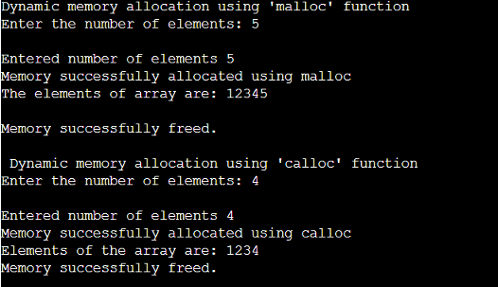

CONCULSION:

Code is run successfully, required output received

